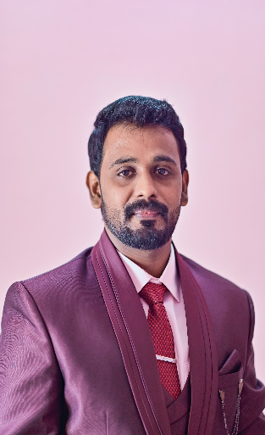

Mr. IMMANUVEL MASILAMANI

Executive Asst (Grade-I) immanuvel@karunya.edu

Academic Background

 | Degree | University | Year
 | M.B.A. | Coimbatore Institute of Engineering & Technology | 2009
 | B.B.A | Theni Kammavar College of Arts & Sciences | 1995
Specializations
- Human Resource Management
- Marketing

INDUSTRIAL EXPERIENCE: (Location - Coimbatore)

- Working as a store Manager in Nilgiris Super Market. (From 2020 to 2023)
- Working as a store Manager in Reliance Clothing India Pvt.Ltd, RS Puram.
(From 2018 to Sep 2020)
- Working as an Assistant Manager in Reliance Clothing India Pvt.Ltd, Brookfield’s.
(From 2016 to 2017)
- Working as a Senior CSA in Reliance Clothing India Pvt.Ltd, Fun Mall.
(From 2015 to 2016)

